Experiment – 15

Aim
To classify the given samples into their respective classes using the Gaussian Naïve Bayes (GaussianNB) classification algorithm for five different datasets: Fruit Classification, Student Placement, Disease Diagnosis, Employee Promotion, and Vehicle Classification.

Algorithm
- Import the required libraries such as GaussianNB, train_test_split, and accuracy_score.
- Create the five datasets with their input features and target classes.
- Separate each dataset into:
  - X – Input features
  - y – Target labels
- Split each dataset into training and testing data using train_test_split().
- Create a Gaussian Naïve Bayes classifier using GaussianNB().
- Train the classifier using the training data.
- Test the model and calculate its accuracy.
- Provide the given new sample as input to the trained model.
- Predict the class of the new sample using model.predict().
- Display the predicted class and accuracy for all five datasets.

Program:
# ============================================================
# NAIVE BAYES CLASSIFICATION - 5 DATASETS
# Gaussian Naive Bayes using sklearn
# ============================================================

from sklearn.naive_bayes import GaussianNB
from sklearn.model_selection import train_test_split
from sklearn.metrics import accuracy_score

# ============================================================
# DATASET 1: FRUIT CLASSIFICATION
# ============================================================

print("=" * 60)
print("DATASET 1: FRUIT CLASSIFICATION")
print("=" * 60)

# Features: Weight, Diameter, Sweetness
X_fruit = [
[150, 7.5, 90],
[160, 7.8, 88],
[145, 7.3, 91],
[120, 5.5, 70],
[125, 5.8, 72],
[130, 6.0, 74],
[155, 7.6, 89],
[118, 5.4, 69],
[148, 7.4, 92],
[122, 5.7, 71]
]

y_fruit = [
"Apple", "Apple", "Apple", "Orange", "Orange",
"Orange", "Apple", "Orange", "Apple", "Orange"
]

# Split dataset
X_train, X_test, y_train, y_test = train_test_split(
X_fruit, y_fruit, test_size=0.3, random_state=42
)

# Train model
model_fruit = GaussianNB()
model_fruit.fit(X_train, y_train)

# Test accuracy
y_pred = model_fruit.predict(X_test)
print("Accuracy:", accuracy_score(y_test, y_pred) * 100, "%")

# New sample
new_fruit = [[152, 7.5, 90]]
prediction = model_fruit.predict(new_fruit)

print("New Sample:", new_fruit[0])
print("Predicted Fruit:", prediction[0])

# ============================================================
# DATASET 2: STUDENT PLACEMENT CLASSIFICATION
# ============================================================

print("\n" + "=" * 60)
print("DATASET 2: STUDENT PLACEMENT CLASSIFICATION")
print("=" * 60)

# Features: CGPA, Aptitude Score, Communication Score
X_student = [
[9.2, 90, 88],
[8.8, 85, 82],
[8.5, 80, 79],
[7.2, 72, 70],
[6.8, 68, 65],
[9.0, 92, 90],
[7.5, 75, 74],
[8.6, 84, 81],
[6.5, 60, 58],
[8.9, 88, 86]
]

y_student = [
"Placed", "Placed", "Placed", "Not Placed", "Not Placed",
"Placed", "Not Placed", "Placed", "Not Placed", "Placed"
]

# Split dataset
X_train, X_test, y_train, y_test = train_test_split(
X_student, y_student, test_size=0.3, random_state=42
)

# Train model
model_student = GaussianNB()
model_student.fit(X_train, y_train)

# Test accuracy
y_pred = model_student.predict(X_test)
print("Accuracy:", accuracy_score(y_test, y_pred) * 100, "%")

# New sample
new_student = [[8.7, 86, 84]]
prediction = model_student.predict(new_student)

print("New Sample:", new_student[0])
print("Predicted Placement:", prediction[0])

# ============================================================
# DATASET 3: DISEASE DIAGNOSIS
# ============================================================

print("\n" + "=" * 60)
print("DATASET 3: DISEASE DIAGNOSIS")
print("=" * 60)

# Features: Temperature, Heart Rate, Oxygen Level
X_disease = [
[39.0, 110, 94],
[38.5, 108, 95],
[37.0, 78, 99],
[39.2, 115, 93],
[36.8, 75, 98],
[38.8, 112, 94],
[37.2, 80, 98],
[39.1, 114, 92],
[36.7, 74, 99],
[38.9, 111, 93]
]

y_disease = [
"Positive", "Positive", "Negative", "Positive", "Negative",
"Positive", "Negative", "Positive", "Negative", "Positive"
]

# Split dataset
X_train, X_test, y_train, y_test = train_test_split(
X_disease, y_disease, test_size=0.3, random_state=42
)

# Train model
model_disease = GaussianNB()
model_disease.fit(X_train, y_train)

# Test accuracy
y_pred = model_disease.predict(X_test)
print("Accuracy:", accuracy_score(y_test, y_pred) * 100, "%")

# New sample
new_disease = [[38.7, 109, 94]]
prediction = model_disease.predict(new_disease)

print("New Sample:", new_disease[0])
print("Predicted Disease:", prediction[0])

# ============================================================
# DATASET 4: EMPLOYEE PROMOTION PREDICTION
# ============================================================

print("\n" + "=" * 60)
print("DATASET 4: EMPLOYEE PROMOTION PREDICTION")
print("=" * 60)

# Features: Experience, Performance Score, Training Hours
X_employee = [
[10, 95, 50],
[8, 90, 45],
[7, 88, 40],
[3, 65, 20],
[2, 60, 18],
[9, 93, 48],
[4, 70, 25],
[8, 89, 42],
[2, 58, 15],
[6, 85, 38]
]

y_employee = [
"Promoted", "Promoted", "Promoted", "Not Promoted",
"Not Promoted", "Promoted", "Not Promoted",
"Promoted", "Not Promoted", "Promoted"
]

# Split dataset
X_train, X_test, y_train, y_test = train_test_split(
X_employee, y_employee, test_size=0.3, random_state=42
)

# Train model
model_employee = GaussianNB()
model_employee.fit(X_train, y_train)

# Test accuracy
y_pred = model_employee.predict(X_test)
print("Accuracy:", accuracy_score(y_test, y_pred) * 100, "%")

# New sample
new_employee = [[7, 90, 44]]
prediction = model_employee.predict(new_employee)

print("New Sample:", new_employee[0])
print("Predicted Promotion:", prediction[0])

# ============================================================
# DATASET 5: VEHICLE CLASSIFICATION
# ============================================================

print("\n" + "=" * 60)
print("DATASET 5: VEHICLE CLASSIFICATION")
print("=" * 60)

# Features: Engine Capacity, Weight, Mileage
X_vehicle = [
[100, 95, 70],
[125, 110, 65],
[150, 125, 55],
[800, 850, 22],
[1000, 950, 20],
[1200, 1050, 18],
[110, 100, 68],
[900, 900, 21],
[140, 120, 58],
[1300, 1100, 17]
]

y_vehicle = [
"Bike", "Bike", "Bike", "Car", "Car",
"Car", "Bike", "Car", "Bike", "Car"
]

# Split dataset
X_train, X_test, y_train, y_test = train_test_split(
X_vehicle, y_vehicle, test_size=0.3, random_state=42
)

# Train model
model_vehicle = GaussianNB()
model_vehicle.fit(X_train, y_train)

# Test accuracy
y_pred = model_vehicle.predict(X_test)
print("Accuracy:", accuracy_score(y_test, y_pred) * 100, "%")

# New sample
new_vehicle = [[135, 118, 60]]
prediction = model_vehicle.predict(new_vehicle)

print("New Sample:", new_vehicle[0])
print("Predicted Vehicle Type:", prediction[0])

# ============================================================
# FINAL RESULTS
# ============================================================

print("\n")
print("=" * 60)
print("FINAL PREDICTION RESULTS")
print("=" * 60)

print("1. Fruit Classification :",
model_fruit.predict([[152, 7.5, 90]])[0])

print("2. Student Placement :",
model_student.predict([[8.7, 86, 84]])[0])

print("3. Disease Diagnosis :",
model_disease.predict([[38.7, 109, 94]])[0])

print("4. Employee Promotion :",
model_employee.predict([[7, 90, 44]])[0])

print("5. Vehicle Classification :",
model_vehicle.predict([[135, 118, 60]])[0])

print("=" * 60)

Output:
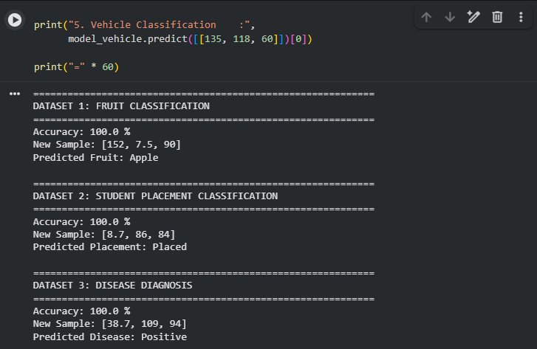

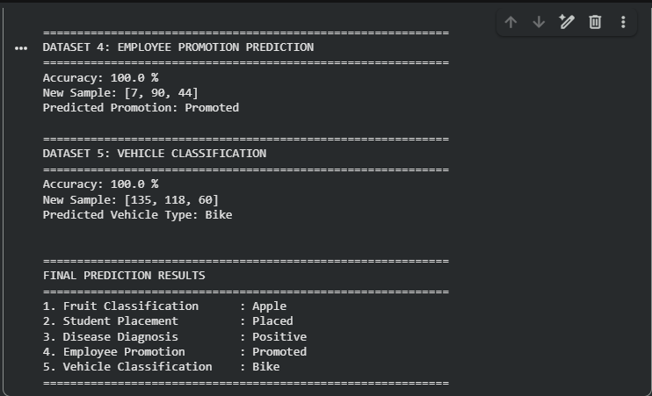

Result
The Gaussian Naïve Bayes algorithm successfully classified the given new samples as follows:
- Fruit Classification: Apple
- Student Placement: Placed
- Disease Diagnosis: Positive
- Employee Promotion: Promoted
- Vehicle Classification: Bike
Thus, the Gaussian Naïve Bayes classifier successfully performed classification on all five datasets.

